Version 1.0

March 20, 2025

System Sequence Diagrams

###### nbcc practicum tool

PRESENTED BY: Valerie Fugere

**Table of Contents**

*Student: choose decision ………………………………………………………………………………………………………… 4*

*Instructor: upload list …………………………………………………………………………………………………………….. 5*

*Admin / Instructor: view list …………………………………………………………………………………………………… 6*

*Admin / Instructor: set due date ……………………………………………………………………………………………. 7*

# **Document Revisions**

|  |  |  |  |
| --- | --- | --- | --- |
| **Number** | **Date** | **Description** | **Resource** |
| 1.0 | 03-20-2025 | Initial Draft | Valerie Fugere |
|  |  |  |  |
|  |  |  |  |
|  |  |  |  |

# **Document Review**

|  |  |  |
| --- | --- | --- |
| **RevisionNumber** | **Date** | **Resource** |
| 1.0 | 03-20-2025 | Neil |
|  |  |  |
|  |  |  |
|  |  |  |

### Student: choose decision

### Instructor: upload list

### Admin / Instructor: view list

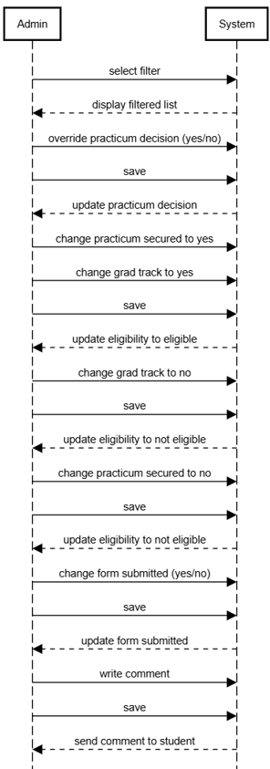

### Admin / Instructor: set due date

